 | UV Black Light Invisible Ink - Red  Safety Data Sheet  Date of issue: 15/01/2023  Date of revision: 15/01/2023  Revised by: David Morissette

- IDENTIFICATION
  - Product identifier
Glow Authority UV Black Light Invisible Ink
  - Other means of identification
UPC 620082001230 (4 Fl Oz, Red)
  - Canadian supplier identifier
Glow Products Canada Inc.
2348 Jean-Talon E, unit 206
Montreal, Quebec, H2E 1V7
  - Emergency telephone number
+1 514-313-6111
- HAZARD IDENTIFICATION
  - Hazard classification (class, category or subcategory) of substance or mixture or a description of the identified hazard for Physical or Health Hazards Not Otherwise Classified:
    - Target organs
Gastrointestinal tract, liver, cardiovascular system, kidney, nervous system
    - GHS classification
Flammable liquids; Skin irritation; Eye irritation; Specific target organ toxicity
  - Label elements
    - Symbol (image) or the name of the symbol
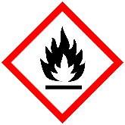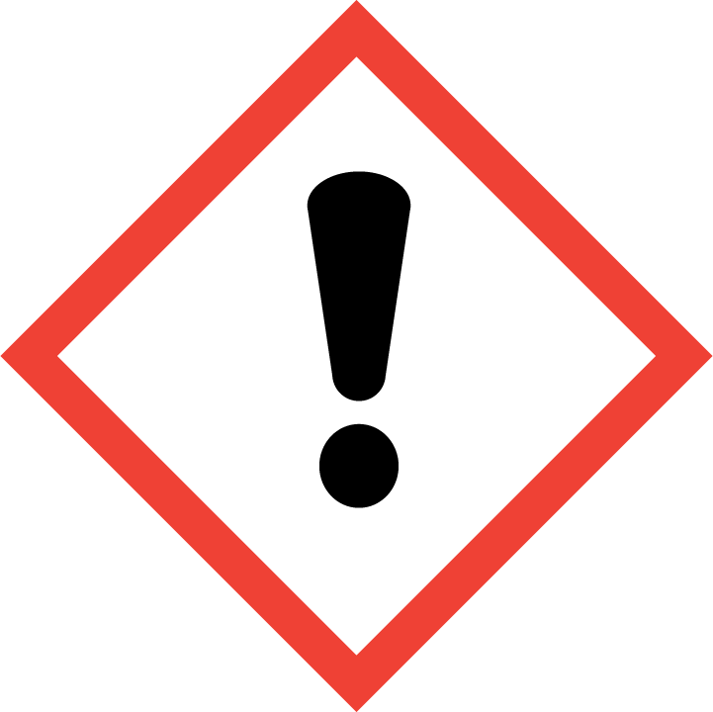
    - Signal word
Danger
    - Hazard statements
Flammable liquid and vapor, may be irritating to sensitive skin, causes serious eye irritation, may cause drowsiness or dizziness.
    - Precautionary Statements
Keep away from heat/sparks/open flames/hot surfaces.
Avoid breathing dust/fume/gas/mist/vapors/spray.
If in eyes: rinse cautiously with water for several minutes. Remove contact lenses/ Continue rinsing.
- COMPOSITION/INFORMATION ON INGREDIENTS
Chemical Name | % | Synonyms | CAS No.
Isopropyl Alcohol 99% | 59 | 2-Propanol, 99%; isopropanol | 67-63-0
Acetone | 40 | Dimethylketone; 2-Propanone | 67-64-1
UV Reactive Pigment | 1

- FIRST-AID MEASURES
  - First-aid measures by route of exposure:
    - Skin contact
Wash off with soap and water
    - Eye contact
Rinse with a generous amount of water. Get medical attention.
    - Ingestion
Inducing vomiting should only be performed under the direct supervision of medical personnel. Never give anything by mouth to an unconscious person. Call a physician or Poison Control Center immediately.
  - Most important symptom and effects
None
  - Immediate medical attention and special treatment
None
- FIRE-FIGHTING MEASURES
  - Suitable extinguishing media
Water spray, foam, dry chemical, carbon dioxide. Alcohol resistant foams (ATC) are preferred, if available.
  - Unsuitable extinguishing media
None known
  - Specific hazards arising from hazardous product
Decomposition materials may emit acrid smoke and irritating fumes.
  - Special protective equipment and precautions for fire-fighters
Never use welding or cutting torch on or near drum (including empty) because product can ignite explosively.
- ACCIDENTAL RELEASE MEASURES
  - Personal precautions, protective equipment and emergency procedures
Wear appropriate personal protective equipment.
  - Methods and materials for containment and cleaning up
Ventilate area of leak or spill. Remove all sources of ignition. Isolate hazard area. Keep unnecessary and unprotected personnel from entering. Contain and recover liquid when possible. Use non-sparking tools and equipment. Collect liquid in an appropriate container or absorb with an inert material (i.e., vermiculite, dry sand, and earth), and place in a chemical waste container. Do not use combustible materials, such as sawdust. Do not flush to sewer! If leak or spill has not ignited, use water spray to disperse the vapors, to protect personnel attempting to stop leak, and to flush spills away from exposures.
- HANDLING AND STORAGE
  - Precautions for safe handling
Protect against physical damage. Store in a cool, dry well-ventilated location, away from any area where the fire hazard. Separate from incompatibles. Storage and use areas should be NO SMOKING areas. Use non-sparking tools and equipment. Containers of this material may be hazardous when empty since the retain product residues (vapors, liquid); observe all warnings and precautions listed for the product.
  - Storage
Store in a cool, dry, well ventilated place, in securely closed original container. Flammable/combustible – keep away from oxidizing agents, heat and flames. Keep out of reach of children.
- EXPOSURE CONTROLS/PERSONAL PROTECTION
  - Control parameters, including occupational exposure guidelines or biological exposure limits and the source of those values
None
  - Appropriate engineering controls
None
  - Individual protection measures
None
- PHYSICAL AND CHEMICAL PROPERTIES
  - Appearance
Clear, colorless liquid
  - Odour
Rubbing alcohol, Fragrant
  - Odour threshold
N/A
  - Melting/Freezing point
Unknown
  - Initial boiling point/boiling range
Unknown
  - Flash point
0C (32F) CC
  - Evaporation rate
Unknown
  - Flammability
Flammable
  - Lower flammable/explosive limit
N/A
  - Upper flammable/explosive limit
N/A
  - Vapour pressure
Unknown
  - Vapour density
Unknown
  - Relative density
N/A
  - Solubility
Miscible in water
  - Partition coefficient – n-octanol/water
N/A
  - Auto-ignition temperature
N/A
  - Decomposition temperature
Unknown
  - Viscosity
Unknown
- STABILITY AND REACTIVITY
  - Reactivity
Unknown
  - Chemical stability
Stable
  - Possibility of hazardous reactions
None
  - Conditions to avoid
Heat, flames, sparks, ignition sources and incompatibles
  - Incompatible materials
Oxidizing materials
  - Hazardous decomposition products
Carbon dioxide and carbon monoxide may form when heated to decomposition
- TOXICOLOGICAL INFORMATION
Oral rat LD50: 5045 mg/kg; skin rabbit LD50: 12.8 gm/kg; inhalation rat LC50: 16,000 ppm/8hour; investigated as a tumorigen, mutagen, reproductive effector.
- ECOLOGICAL INFORMATION
When released into the soil, this material is expected to quickly evaporate. When released into the soil, this material may leach into groundwater. When released into the soil, this material may biodegrade to a moderate extent. When released to water, this material is expected to quickly evaporate. When

released into the water, this material is expected to have a half-life between 1 and 10 days. When released into water, this material may biodegrade to a moderate extent. This material is not expected to significantly bioaccumulate. When released into the air, this material is expected to be readily degraded by reaction with photochemically produced hydroxyl radicals. When released into the air, this material is expected to have a half-life between 1 and 10 days. When released into the air, this material may be removed from the atmosphere to a moderate extent by wet deposition.
- DISPOSAL CONSIDERATIONS
Whatever cannot be saved for recovery or recycling should be handled as hazardous waste and sent to a RCRA approved incinerator or disposed in a RCRA approved waste facility. Processing, use or contamination of this product may change the waste management options. State and local disposal regulations may differ from federal disposal regulations. Dispose of container and unused contents in accordance with federal, state and local requirements.
- TRANSPORT INFROMATION
Proper Shipping Name: ISOPROPANOL
Hazard Class: 3
UN/NA: UN1219
Packing Group: II
Information reported for product/size: 4L
- SAFETY, HEALTH AND ENVIRONMENTAL REGULATIONS SPECIFIC TO THE PRODUCT
No data available
- OTHER INFORMATION
Updated version.

DISCLAIMER:
The information accumulated herein is believed to be accurate and represents the best data currently available. It is the user’s responsibility to determine suitability of use. No warranty, expressed or implied, is made and Les Produits Glow Canada Inc. assumes no legal responsibility or liability resulting from its use. Materials comprising <1% by weight, or <0.1% by weight if the chemical is a carcinogen, are not listed herein.

